Interpreting Graphics: Taxonomy

Use the Web on the second page to answer the following questions:

Answer true or false to the following statements. Use the graphic to determine the answers.

1. ______ Dogs belong to the order Felidae.

2. ______ A fox belongs to the phylum Arthropoda.

3. ______ Snakes belong to the phylum Reptilia.

4. ______ Lions belong to the class mammalia

5. ______ All arthropods belong to the Class Insecta

6. ______ All rodents belong to the phylum chordata.

7. ______ All amphibians belong to the class reptilia.

8. _______ All primates are mammals.

9. _______ The class mammalia includes dogs, cats and rats.

10. ______ A lion belongs to the genus Felis.

11. ______ All mammals are primates.

12. ______ Insects and lobsters are arthropods.

In each set, circle the pair that is most closely related.

13. snakes & crocodiles | snakes & frogs

14. rats & cats | cats & dogs

15. insects & lobsters | insects & birds

16. lions & tigers | lions & cougars

17. foxes & rats | foxes & dogs

18. cats & dogs | cats & lions

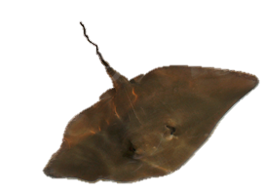

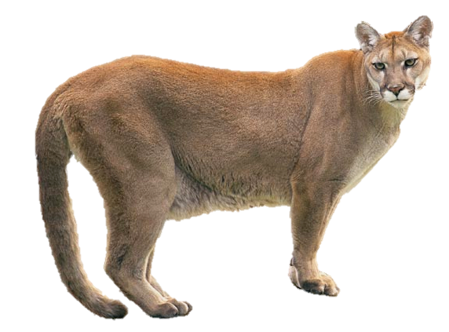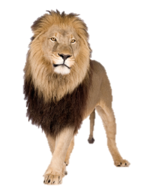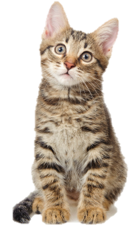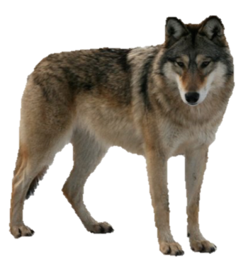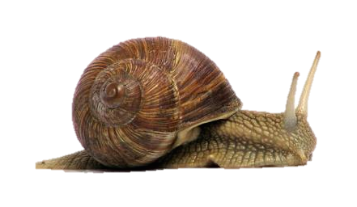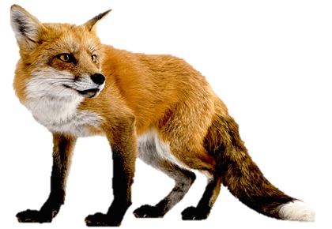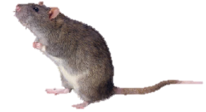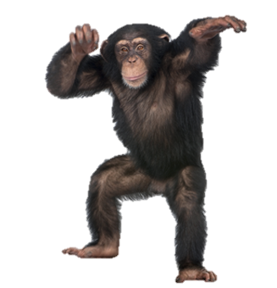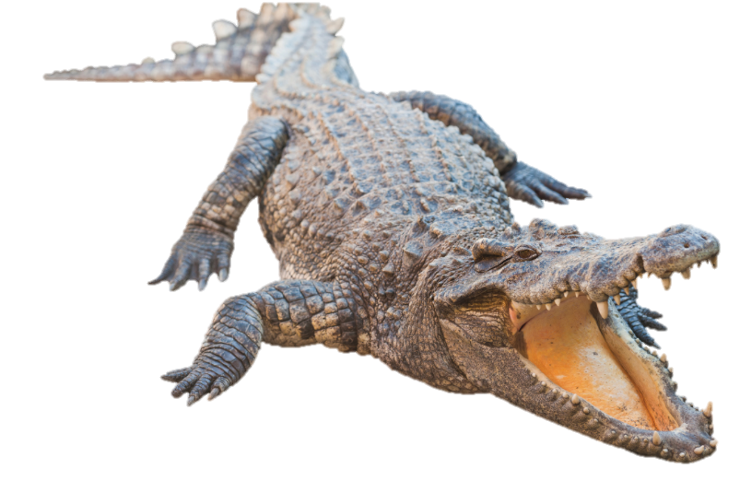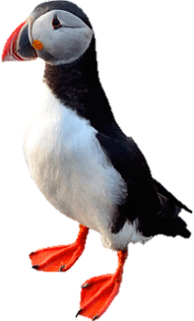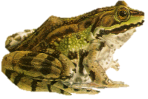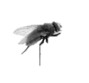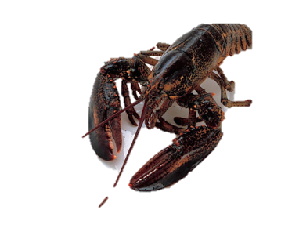

Panthera leo

Felis domesticus

Felis concolor

Canis familiaris

Canis lupis

Genus Canis

Genus Vulpes

Genus Felis

Genus Panthera

Family Felidea

Family Canidea

Order Primate

Order Carnivora

Order Rodentia

Order Crocodilia

Phylum Cordata

Class Mamalia

Class Aves

Class Reptilia

Class Agnatha

Class Amphibia

Class Crustacea

Class Insecta

Phylum Arthopoda

Phylum Mollusca

Kingdom: Animalia